Contact:
Julie Goldfischer – Executive Director
Premier Cares Foundation
Phone: 845.453.1160
jgoldfischer@premiercaresfoundation.org

Press Release

Premier Cares Foundation’s 5th Annual “Challenge Your Colon” Chili Festival Raises Over $52,000 to Help Hudson Valley Patients Battling Gastrointestinal and Urological Diseases

Poughkeepsie, NY, March 21, 2016 – The 5th Annual ‘Challenge Your Colon’ Chili Festival was held on Sunday, March 13 at Villa Borghese in Wappingers Falls. The event raised over $52,000 to help Hudson Valley patients who are battling gastrointestinal and urological diseases.
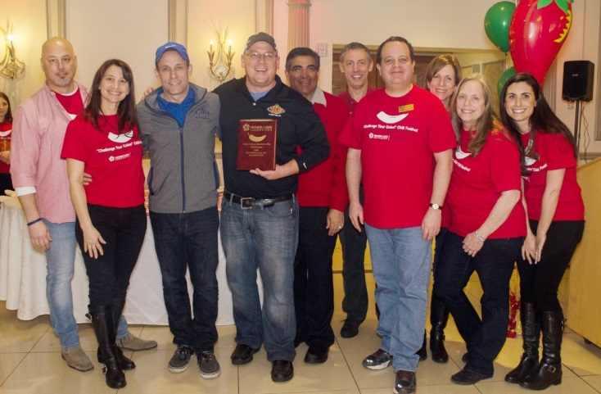
More than 500 people gathered to sample delicious chili, cornbread and chocolate chip cookies from area restaurants. This year’s event also featured an expanded Kid’s Room with fun crafts, games, activities and musical entertainment from Stringendo’s Raspberry Fiddlers as well as the TapSnap photo booth. Q92’s radio host Joe Daily was also on hand to emcee the event.
Premier Cares Foundation board members present the Premier Award for Best Chili to Texas Roadhouse.
“It is heartwarming to know that so many people from the Hudson Valley have made the Colon Cancer Awareness Chili Festival a staple in their spring schedule. In designing the Chili Festival over five years ago, our hope was that people would come out for a delicious and fun, family-friendly afternoon, to raise awareness on a topic that many tend to shy away from. With the expansion of our event each year, we have been able to partner with so many more organizations, such as Healthquest Nutrition, Sparrow's Nest, and Putnam Ridge Nursing Home. We were so fortunate to have so many incredible restaurants and local businesses supporting our event each year. The best part for me is working with over 90 volunteers, many of whom are colon cancer survivors, who all care about helping to prevent the dreaded, yet preventable disease of colon cancer’ said Julie Goldfischer, Executive Director of Premier Cares Foundation.
Chilis, cornbreads, and chocolate chip cookies were judged by professional culinary judges in blind tastings as well as by People’s Choice voting. And the winners are:

Texas Roadhouse - Premier Award Best Chili
Mill House Brewery - People's Choice Award for Best Chili
Mole Mole - Most "Creative" Chili
Adam's Fairacre Farms - Premier Award for Best Veggie Chili
Crooked Rooster - People's Choice for Best Veggie Chili
YOLO - Premier Award for Best Cornbread
Mill House Brewery - People's Choice Award for Best Cornbread
On-A-Stick Bakery - Premier Award for Best Chocolate Chip Cookie
Brew Sky - People's Choice Award for Best Chocolate Chip Cookie
Durant's Party Rentals - Table with Best Country Flair
Mole Mole - Table with Best Country Attire

The mission of Premier Cares Foundation is to provide support, education, awareness and treatment to those individuals in the community lacking sufficient funds to address significant urologic and digestive issues including but not limited to prostate and colon cancers. For more information please visit www.premiercaresfoundation.org

